**Report on project submission 3 for CSCE 636- Spring 2021**

**Bahareh Alizadeh Kharazi**

**March 11, 2021**

**Abstract**

In this project, the goal is to detect the action of shaking head in video clips. A transfer learning approach is proposed in this project which was developed based on using ResNet50 and replacing its first layer with one LSTM layer and three other dens layers. A dataset is created by the author which 50% of it is labeled as shaking head. The test accuracy of this model on the 30% of the entire dataset was achieved as 77% which is acceptable. However, the limited amount of videoclips in the dataset, still questions the generalizability of the model.

**Collecting training dataset**

The topic selected for this project was “Shaking-head”. To create a dataset for training the model, I had to search for videoclips that have the action “shaking-head” in one clip. Since most videos available on the web have different actions in one clip, I decided to find GIF files (The Graphics Interchange Format) that are commonly used file types in social media that focuses on one action at a time. This trick helped me to train my model easily on the dataset with limited amount of data for my first submission.

For the first submission, I collected 50 photos containing shaking-head action and 50 photos containing other actions. To organize the data I named all vidoes with shaking-head action and videos with non-shaking-head action as “shakinghead_number” and “other_number”, respectively. All these folders were moved to Google Drive folders to be used in Google Collab.

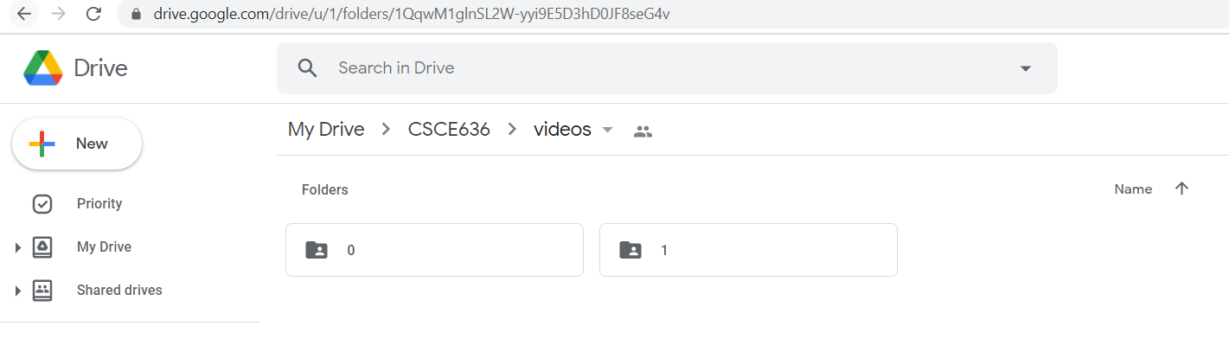

Folder 0 contains all videos with other actions and folder 1 contains videos with shaking-head action.

**Preprocessing of the dataset**

To prepare videoclips for my model, first I load the modules that I need. I also, mount the Google Drive in the Google Collab:

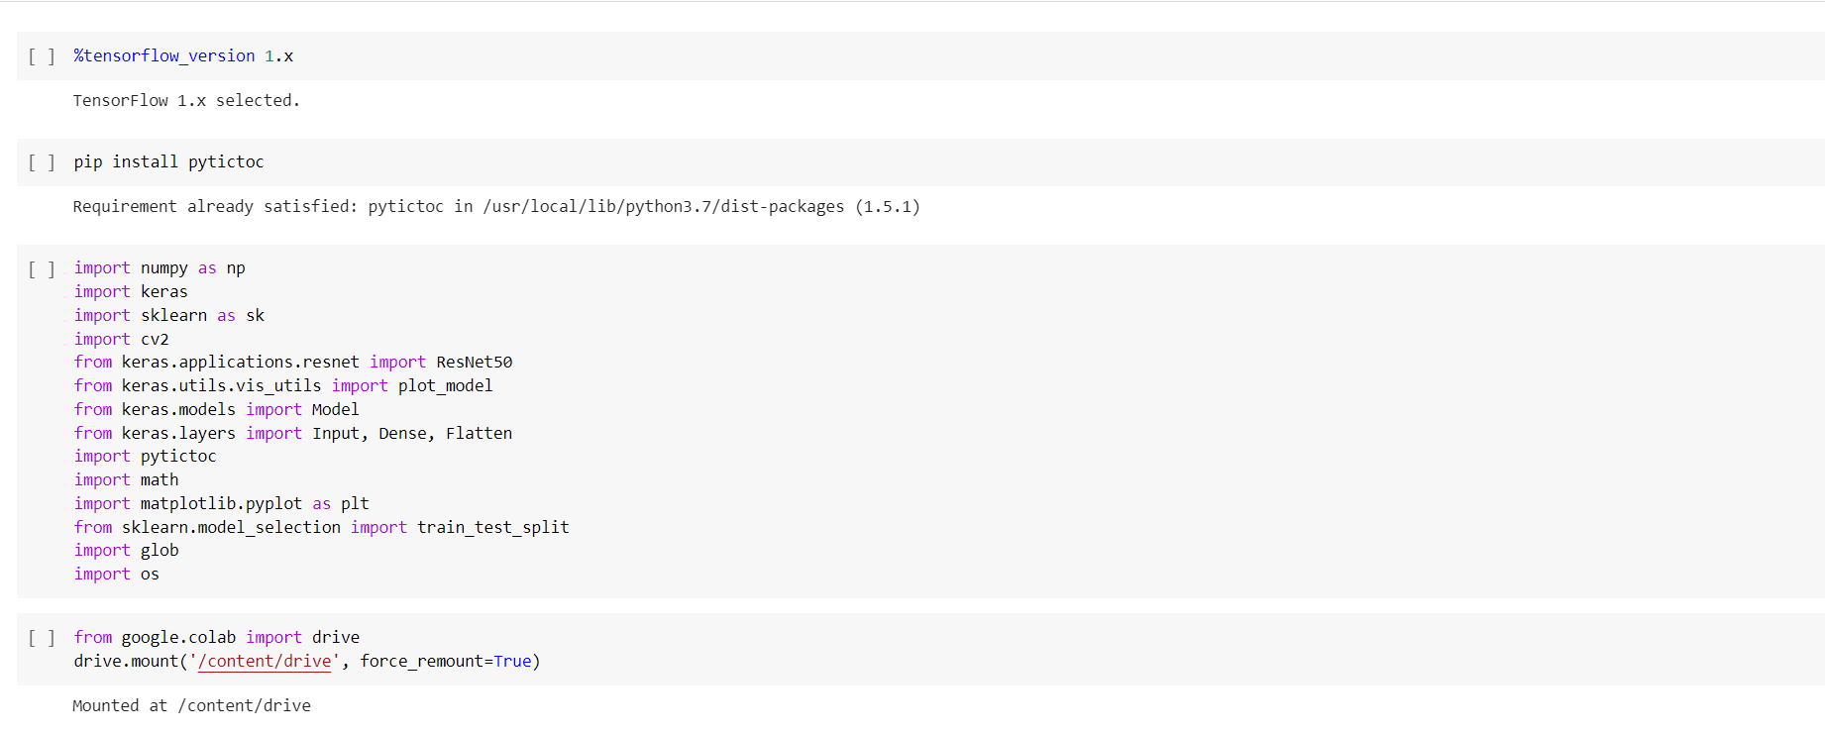

Then videos in each folder will be converted to frames (as image) and saved to other folder. The process for videos with label 1 is shown below:

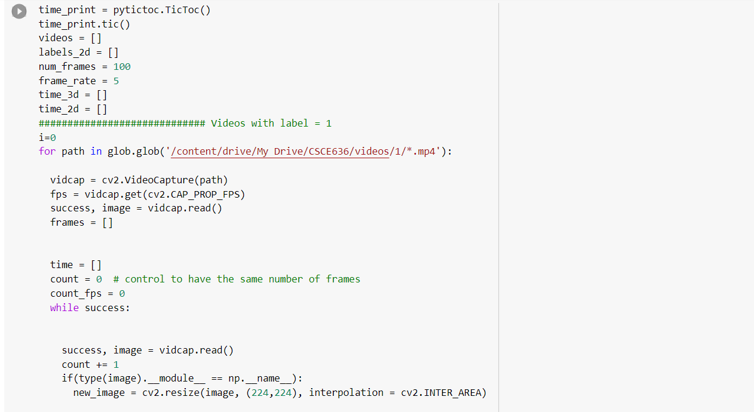

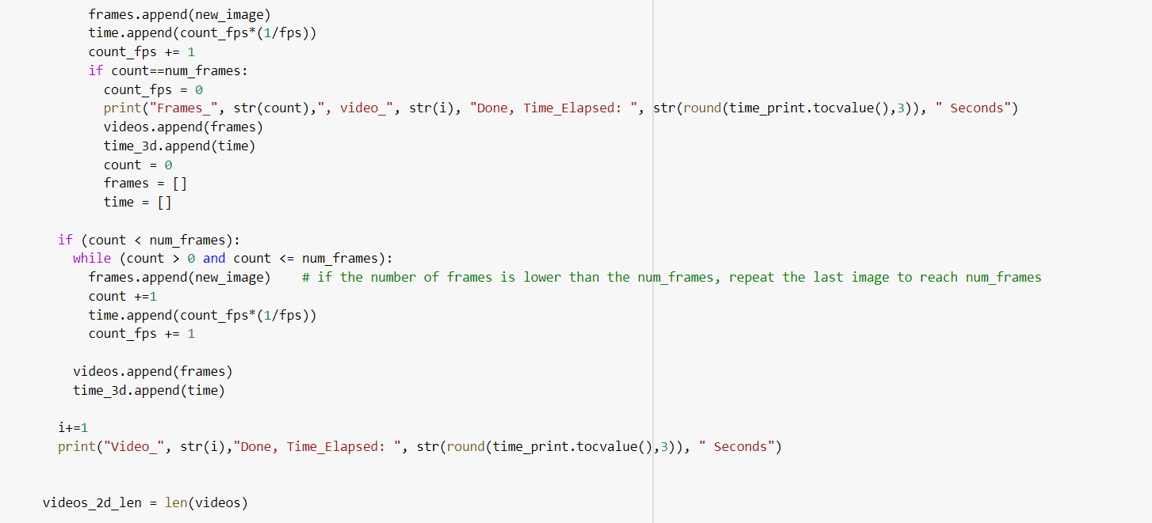

Then all images will be reshaped to a single shape size.

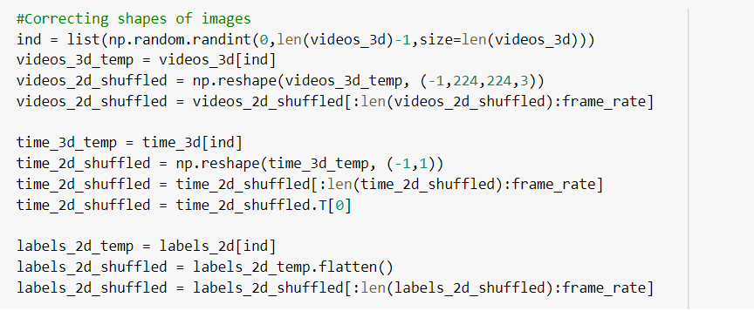

Since processing all images every time is time consuming, I saved all the frames as numpy file to speed up the process for further work. Although currently the number of training image in our dataset is limited, but this approach will save time when my dataset gets larger later.

**Selecting a model**

I used transfer learning on ResNet50 by excluding the first layer and adding four other layers to it (one ConvLSTM2D and three dense layers).

First we load the modules:

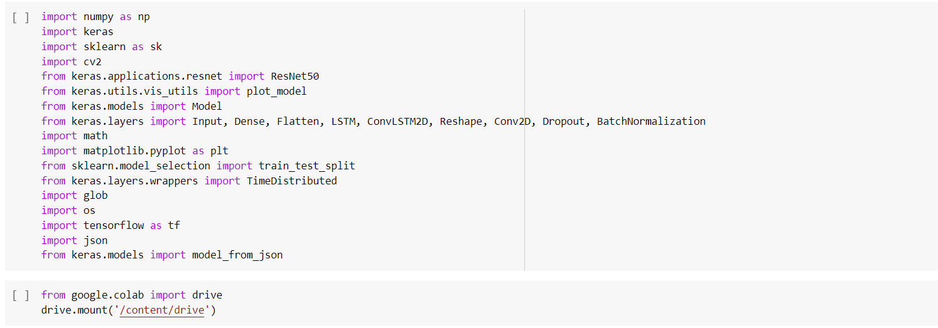

Then we load the numpy data that we created in the previous section:



Each second in the videoclips is going to be divided to 20 frames:

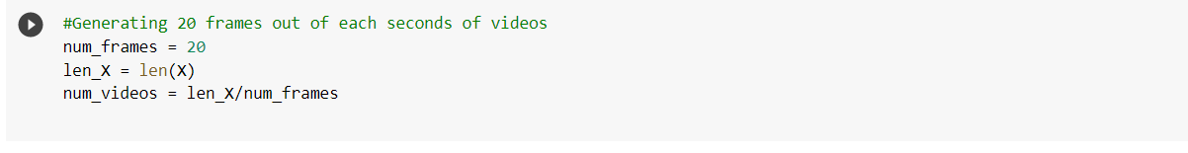

Also, we took 70% of the dataset as the training set and the rest for the test set.

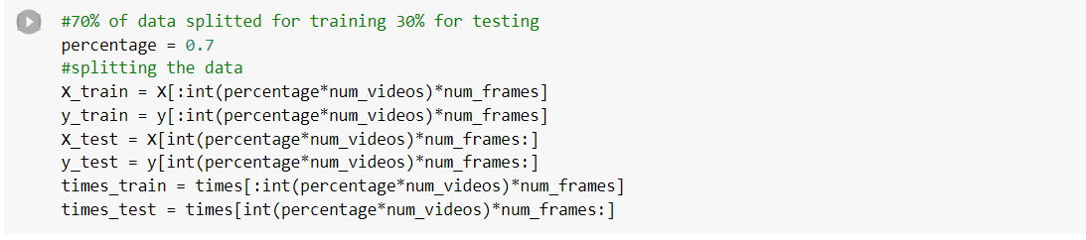

**Training and testing the model on the dataset**

Then we apply transfer learning as stated before, without training the wights of 49 layers of the ResNet model. We only train the weights for the added four layers.

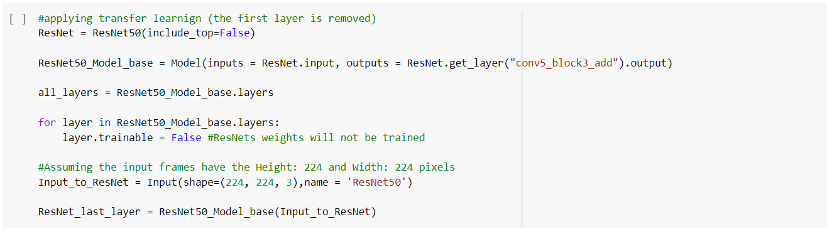

We check the name of the last layer in ResNet (below) and add it as the output in the code above:

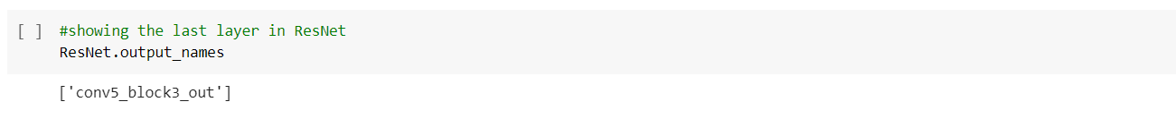

Here, four layers are added to the ResNet model. The first one is ConvLSTM2D and the other three are three dens layers (two with relu active function and one with sigmoid active function). The last layer has one node because our output is binary (0 or 1).

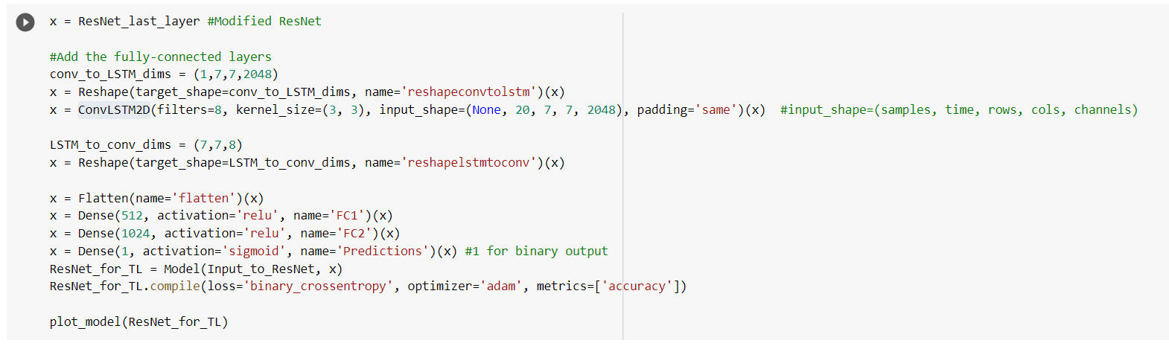

The plot of the model is shown below:

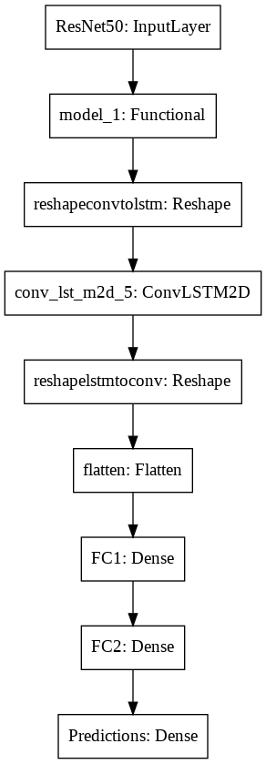

Now we fit the ResNet model on our dataset with batch_size=20 and epoch=20. The training accuracy is achieved 99.75% and the test accuracy is obtained 82.64%. Because we have limited amount of data for the first submission, the accuracy varies a lot. By adding more data, our model will be more robust in terms of its accuracy.



Epoch 1/20

81/81 [==============================] - 8s 74ms/step - loss: 0.1359 - accuracy: 0.9370 - val_loss: 0.6610 - val_accuracy: 0.8681

Epoch 2/20

81/81 [==============================] - 5s 59ms/step - loss: 0.0189 - accuracy: 0.9938 - val_loss: 0.8774 - val_accuracy: 0.8403

Epoch 3/20

81/81 [==============================] - 5s 59ms/step - loss: 0.0245 - accuracy: 0.9895 - val_loss: 1.4699 - val_accuracy: 0.7264

Epoch 4/20

81/81 [==============================] - 5s 59ms/step - loss: 0.0369 - accuracy: 0.9883 - val_loss: 0.8230 - val_accuracy: 0.8153

Epoch 5/20

81/81 [==============================] - 5s 59ms/step - loss: 0.0167 - accuracy: 0.9938 - val_loss: 0.9994 - val_accuracy: 0.8611

Epoch 6/20

81/81 [==============================] - 5s 59ms/step - loss: 0.0408 - accuracy: 0.9883 - val_loss: 1.0026 - val_accuracy: 0.8389

Epoch 7/20

81/81 [==============================] - 5s 59ms/step - loss: 0.0230 - accuracy: 0.9901 - val_loss: 0.9920 - val_accuracy: 0.8306

Epoch 8/20

81/81 [==============================] - 5s 59ms/step - loss: 0.0157 - accuracy: 0.9957 - val_loss: 1.0627 - val_accuracy: 0.8347

Epoch 9/20

81/81 [==============================] - 5s 59ms/step - loss: 0.0093 - accuracy: 0.9975 - val_loss: 1.2372 - val_accuracy: 0.8361

Epoch 10/20

81/81 [==============================] - 5s 59ms/step - loss: 0.0067 - accuracy: 0.9975 - val_loss: 1.4526 - val_accuracy: 0.8347

Epoch 11/20

81/81 [==============================] - 5s 59ms/step - loss: 0.0105 - accuracy: 0.9975 - val_loss: 1.0312 - val_accuracy: 0.8236

Epoch 12/20

81/81 [==============================] - 5s 59ms/step - loss: 0.0086 - accuracy: 0.9975 - val_loss: 1.4540 - val_accuracy: 0.8417

Epoch 13/20

81/81 [==============================] - 5s 59ms/step - loss: 0.0099 - accuracy: 0.9951 - val_loss: 2.5456 - val_accuracy: 0.7361

Epoch 14/20

81/81 [==============================] - 5s 59ms/step - loss: 0.0678 - accuracy: 0.9846 - val_loss: 0.8886 - val_accuracy: 0.8069

Epoch 15/20

81/81 [==============================] - 5s 59ms/step - loss: 0.0336 - accuracy: 0.9895 - val_loss: 1.1932 - val_accuracy: 0.8417

Epoch 16/20

81/81 [==============================] - 5s 59ms/step - loss: 0.0709 - accuracy: 0.9753 - val_loss: 0.7298 - val_accuracy: 0.8153

Epoch 17/20

81/81 [==============================] - 5s 59ms/step - loss: 0.0135 - accuracy: 0.9957 - val_loss: 0.6954 - val_accuracy: 0.8500

Epoch 18/20

81/81 [==============================] - 5s 59ms/step - loss: 0.0096 - accuracy: 0.9969 - val_loss: 0.9194 - val_accuracy: 0.8389

Epoch 19/20

81/81 [==============================] - 5s 59ms/step - loss: 0.0102 - accuracy: 0.9963 - val_loss: 1.2448 - val_accuracy: 0.8208

Epoch 20/20

81/81 [==============================] - 5s 60ms/step - loss: 0.0091 - accuracy: 0.9975 - val_loss: 0.8940 - val_accuracy: 0.8264

<tensorflow.python.keras.callbacks.History at 0x7f33ebea6390>

The plot of the ResNet model’s base is shown below (you need to zoom in to the picture):



**Testing the model on video clips on youtube**

Now that we have our model trained on our dataset, we can test our model on new videoclips. The process of testing the model is elaborated in the following.

We download YouTube videoclips and move them into the folder in the Google Drive and set the test path to its directory:



Again, we convert the video into frames and save them as image files. We randomly select frames out of each video.

Here we call the model to predict the label of frames in the test data:



And then we plot the predicted label for each frame in the video. For this sample video, the shaking-head action is detected which was correct. For each video lips in the test set, we repeat the same process and then we upload true positive samples in the ilab website.

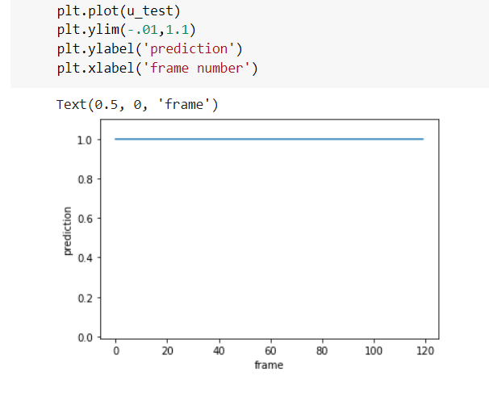

**Project submission 3 (Date: 03/11/2021)**

**Collecting training dataset**

In the third submission of the project I changed my topic to Cooking/Cutting. I collected 18 long video files (total size was 57.3 MB) that contained cutting activity. Some video clips were collected from a publicly available dataset and other videos were collected from YouTube.

**Preprocessing of the dataset**

The preprocessing section was not changed comparing to the previous submission. All videos were uploaded to the Google Colab frames were extracted from videos and saved as numpy files.

**Selecting a model**

A transfer learning is used on ResNet50 by excluding the first layer and adding four other layers to it (one ConvLSTM2D and three dense layers).

Each second in the videoclips is going to be divided to 20 frames:

Also, we took 70% of the dataset as the training set and the rest for the test set.Then we apply transfer learning as stated before, without training the wights of 49 layers of the ResNet model. We only train the weights for the added four layers.

Here, four layers are added to the ResNet model. The first one is ConvLSTM2D and the other three are three dens layers (two with relu active function and one with sigmoid active function). The last layer has one node because our output is binary (0 or 1).



Train on 4120 samples, validate on 1780 samples

Epoch 1/20

4120/4120 [==============================] - 14s 3ms/step - loss: 0.0046 - accuracy: 0.9988 - val_loss: 0.5636 - val_accuracy: 0.8994

Epoch 2/20

4120/4120 [==============================] - 13s 3ms/step - loss: 0.0655 - accuracy: 0.9789 - val_loss: 1.1785 - val_accuracy: 0.7573

Epoch 3/20

4120/4120 [==============================] - 13s 3ms/step - loss: 0.0646 - accuracy: 0.9748 - val_loss: 0.3715 - val_accuracy: 0.8646

Epoch 4/20

4120/4120 [==============================] - 13s 3ms/step - loss: 0.0318 - accuracy: 0.9905 - val_loss: 0.7867 - val_accuracy: 0.8399

Epoch 5/20

4120/4120 [==============================] - 13s 3ms/step - loss: 0.0208 - accuracy: 0.9934 - val_loss: 0.9298 - val_accuracy: 0.8449

Epoch 6/20

4120/4120 [==============================] - 13s 3ms/step - loss: 0.0120 - accuracy: 0.9959 - val_loss: 1.8405 - val_accuracy: 0.7854

Epoch 7/20

4120/4120 [==============================] - 13s 3ms/step - loss: 0.0110 - accuracy: 0.9961 - val_loss: 1.3531 - val_accuracy: 0.8067

Epoch 8/20

4120/4120 [==============================] - 13s 3ms/step - loss: 0.0234 - accuracy: 0.9910 - val_loss: 1.9183 - val_accuracy: 0.8000

Epoch 9/20

4120/4120 [==============================] - 13s 3ms/step - loss: 0.0300 - accuracy: 0.9913 - val_loss: 0.9928 - val_accuracy: 0.6657

Epoch 10/20

4120/4120 [==============================] - 13s 3ms/step - loss: 0.0319 - accuracy: 0.9915 - val_loss: 0.6522 - val_accuracy: 0.8034

Epoch 11/20

4120/4120 [==============================] - 13s 3ms/step - loss: 0.0392 - accuracy: 0.9874 - val_loss: 1.1651 - val_accuracy: 0.7264

Epoch 12/20

4120/4120 [==============================] - 13s 3ms/step - loss: 0.0122 - accuracy: 0.9951 - val_loss: 1.4307 - val_accuracy: 0.6056

Epoch 13/20

4120/4120 [==============================] - 13s 3ms/step - loss: 0.0073 - accuracy: 0.9973 - val_loss: 1.5495 - val_accuracy: 0.5876

Epoch 14/20

4120/4120 [==============================] - 13s 3ms/step - loss: 0.0207 - accuracy: 0.9910 - val_loss: 0.7260 - val_accuracy: 0.7449

Epoch 15/20

4120/4120 [==============================] - 13s 3ms/step - loss: 0.0112 - accuracy: 0.9968 - val_loss: 1.2824 - val_accuracy: 0.8157

Epoch 16/20

4120/4120 [==============================] - 13s 3ms/step - loss: 0.0024 - accuracy: 0.9995 - val_loss: 1.0874 - val_accuracy: 0.8393

Epoch 17/20

4120/4120 [==============================] - 13s 3ms/step - loss: 0.0026 - accuracy: 0.9988 - val_loss: 1.8460 - val_accuracy: 0.8202

Epoch 18/20

4120/4120 [==============================] - 13s 3ms/step - loss: 0.0034 - accuracy: 0.9990 - val_loss: 1.4922 - val_accuracy: 0.8213

Epoch 19/20

4120/4120 [==============================] - 13s 3ms/step - loss: 8.0434e-04 - accuracy: 1.0000 - val_loss: 1.6618 - val_accuracy: 0.8118

Epoch 20/20

4120/4120 [==============================] - 13s 3ms/step - loss: 0.0215 - accuracy: 0.9915 - val_loss: 0.2597 - val_accuracy: 0.9107

<keras.callbacks.callbacks.History at 0x7f75664d90d0>

The accuracy on the training set is 99.15% and the accuracy on the test set is 91.07%.

**Testing the model on YouTube videos.**

Again, we convert the video into frames and save them as image files.

Here we call the model to predict the label of frames in the test data:

And then we plot the predicted label for each frame in the video. For this sample video, the shaking-head action is detected which was correct. For each video lips in the test set, we repeat the same process and then we upload true positive samples in the ilab website by a JSON file named CSCE636_baharealik_V3_JSONfile.

An example of a labeled Youtube video by the model is shown below:

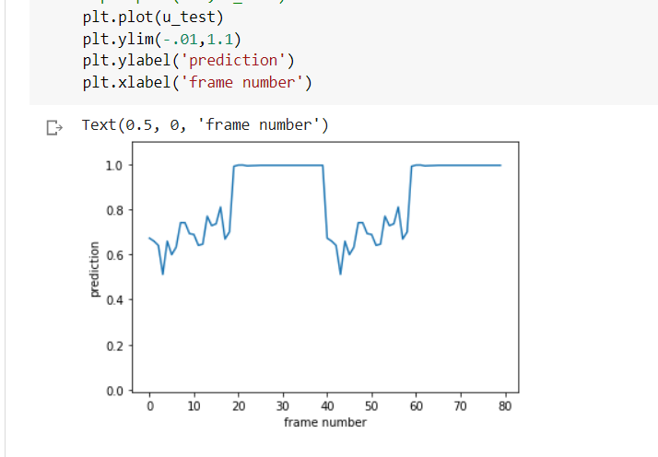

**Discussion:**

When I was assessing detected positives of test set, I found out that the model cannot detect cutting when the knife is not visible (when the knife is held by a person right in front of the camera. But when the person holds the knife in sideways, the cutting action is recognized. Moreover, when the camera is zoomed on the cutting action, the action is not recognized anymore. In the next submission, I need to collect more data for cutting activity and reduce the false negative of the model.

**Project submission 5 (Date: 03/25/2021)**

I tried to use different epochs and batch size in this model. I also automated some parts of the model. I also added some new data to my training set. I also added some new data to my test set. I changed how the model was drawing diagrams (previously the diagram was prediction over frame. But now it is prediction over time).

New diagrams are added in this submission:

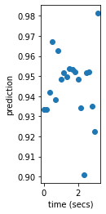

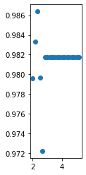

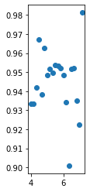

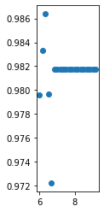

Videos are now searched directly from Youtube.

import pytube

from pytube import YouTube

import urllib.request

# yt = YouTube("https://www.youtube.com/watch?v=n06H7OcPd-g")

# yt = yt.get('mp4', '720p')

# yt.download('/path/to/download/directory')

searchIDs=['slice fruit','vegetables cutting skill', 'fruit cutting', 'cooking cut']

# os.chdir("/content/drive/My Drive/CSCE636/3_test_Youtube")

downVid=[]

for searchID in searchIDs:

    vidSearch = VideosSearch(searchID, limit=2)

    print(searchID)

    id=vidSearch.result()['result'][0]['id']

    url='https://www.youtube.com/watch?v='+id

    print(url)

    youtube = pytube.YouTube(url)

    video = youtube.streams.first()

    video.download('/content/drive/My Drive/CSCE636/3_test_Youtube')

Detected action with an average confidence interval > 95% are reported in the JSON file.

**Project submission 6 (Date: 04/01/2021)**

Submission 6

I added several videos to my test dataset, and training dataset. But based on the recent update from the instructor, I removed those that humans are not seen in the videos.